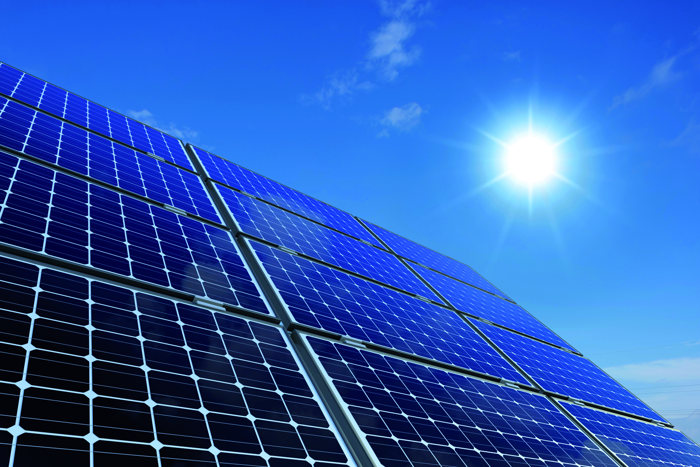



PV Cooler

*A Proposal To EDF EN*

*Client*

11 09 2013



Photovoltaic Cooling System

The effect of temperature

Photovoltaic cells performance depends on ambient temperature. In order to generate electrical power, In the process of converting sunlight to effective current most of the available energy received by sun light radiation is dissipated in the form of heat. Only 10-20% of this energy is converted to useful electrical power. Heat is a form of energy which requires physical means for transfer. It is not possible to simply get rid of heat; it needs to be transferred by one of four forms: Conduction, Convection, Radiation or Phase change. PV Cooler uses water to perform two methods of heat transfer. PV panels sprayed with room temperature water conduct heat to the fluid raising the water temperature and lowering panel ambient temperature. At the second stage, water changes phase to vapor removing an additional substantial amount of heat.

**Hard Water**

Hard water forms deposits that stick to PV panels. These deposits, called "scale", are composed mainly of calcium carbonate (CaCO3), magnesium hydroxide (Mg(OH)2), and calcium sulfate (CaSO4). Calcium and magnesium carbonates tend to be deposited as off-white solids on the surface of the PV panel. This precipitation (formation of an insoluble solid) is principally caused by thermal decomposition of bicarbonate ions but also happens to some extent even without such ions. The resulting build-up of scale restricts sun light reducing cell efficiency over time.

**Water Treatment**

PV Cooler addresses hard water by carefully filtering it using a four stage reverse osmosis system

Reverse osmosis (RO) is a water purification technology that uses a semipermeable membrane. In RO, an applied pressure is used to overcome osmotic pressure, a colligative property that is driven by chemical potential, a thermodynamic parameter. RO can remove many types of molecules and ions from solutions and is used in both industrial processes and in producing potable water. The result is that the solute is retained on the pressurized side of the membrane and the pure solvent is allowed to pass to the other side. Filtered water used for cooling contains less than 10ppm of calcium carbonate and magnesium hydroxide salts which means it can be used safely over extensive periods without causing scale. An additional advantage arises from the readily available treated water on site which can be used to clean panels safely.

Algorithm

**PV cooler** uses a water saving energy maximizing automatic control algorithm which runs on a microcontroller. A control loop measures the outside air temperature, PV panel temperature and sun radiation; this information is used to determine the amount of water required to cool the panels as both temperature and radiation vary. The water supply is modulated in an inverse linear ratio. The typical range for PV panels can be from 20⁰C to 80 ⁰C as the outside ambient temperature varies from 20⁰C to 40⁰C.

11 09 2013

Place Logo Or

Company Name Here

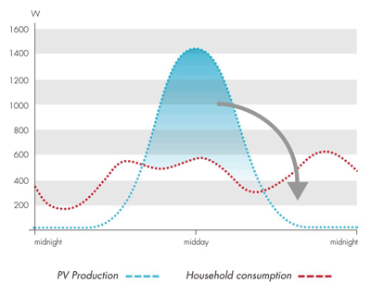

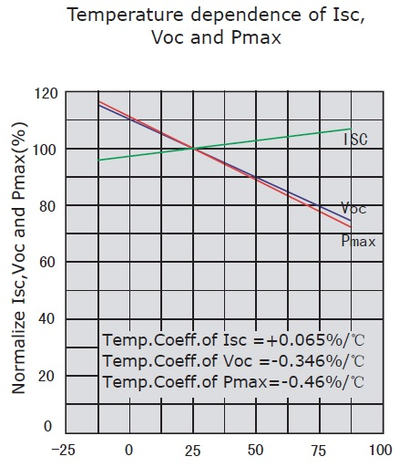

PV Cooler

performance gain

The output of solar cells is affected by ambient temperature. As a result the power output will be reduced by between 0.25%(amorphous cells) and 0.5%(most crystalline cells) for each degree C of temperature rise.   
Panel temperatures in the summer in warm climates can easily reach 70oC resulting in a 22% reduction in output compared to the rated output at 25oC. PV Coolers objective is to operate at high temperatures with strong sun radiation. These conditions usually occur during the peak production ours which are typically between 10:00 PM to 14:00 PM. When panels are effectively cooled during peak production, a 20% gain can easily be achieved. Cooling at lower radiation periods has a lower performance gain and therefor is unnecessary.

PV Cooler

11 09 2013

|  |  |  |  |
| --- | --- | --- | --- |
|  | ₪ 12,000 | ₪ 10,000 | ₪ 8,000 |
| ₪ 0.50 | 17% | 21% | 27% |
| ₪ 0.70 | 27% | 33% | 41% |
| ₪ 0.80 | 32% | 39% | 49% |
| ₪ 1.00 | 42% | 51% | 63% |

The table above displays IRR values with various system cost/feed in tariff scenarios.

Unit price reduction depends on system scale.

PV Cooler pilot

Cooling PV panels with water requires special attention to the amount of water used due to the cost of water and mainly the cost of producing high quality treated water with less than 10 ppm. Fortunately, the narrow window of operating hours between 10:00 am and 14:00 pm requires less than 4 liters/day/panel(2m²) . As an example a 50KW string containing 200 panels would require 800 liters a day. Commercial water is sold at 2₪ per 1000 liters which means water would cost an approximate 60₪ a month. The following table shows an IRR of 27%. Scaling the system could reduce cost considerably as water treatment equipment price would drop drastically.

|  |  |
| --- | --- |
| System size | 50 KW |
| Cost | ₪12,000 |
| Feed in tariff | ₪0.70 |
| Water | ₪720 |
| Annual income | ₪57,750 |
| 7% Gain | ₪4,043 |
| **Revenue** | **₪3,323** |

**Zero Foot Print Pilot**

Due to overall system simplicity and a minimal interface with existing PV plants it is possible to install the PV Cooler and then later remove it leaving a zero foot print. All irrigation system parts simply click on to the solar panels, no glue or holes or screws necessary. The water purification system is completely independent and requires a standalone tank, a pump and a filtering system. Standard irrigation pipes are zip tied to a string of panels. Valves and pumps are controlled via an independent microcontroller which will be located in a water proof container. Data from the system will be logged remotely.

**Prototype**

PVCooler is at prototype stage. This means further development is required to produce a fully functional high quality product. Plastic molds need to be produced to mass produce sprinkler clips.

We propose to conduct a prototype installation on a 50kw string at a site that has several similar strings so that a performance comparison under identical conditions can be generated.

**Cost and timeline**

Completing the sprinkler clip molds and installing PVCooler on 200 panels with a 1 cubic meter purified water tank will cost approximately 50,000₪. This amount will include all hardware and software to successfully install the prototype within 30 working days. Appendix 1 shows images and results from a an early attempt at the solution.



PV Cooler Pilot Offer

11 09 2013

Place Logo Or

Company Name Here

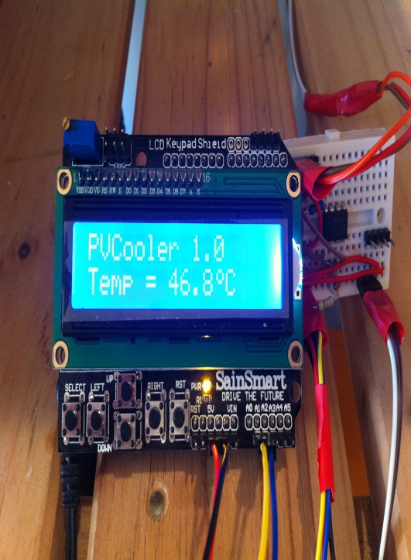

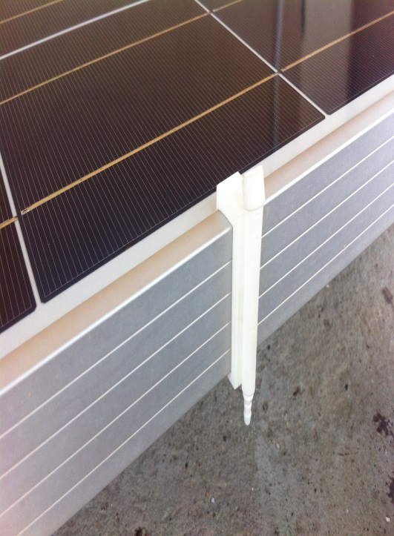

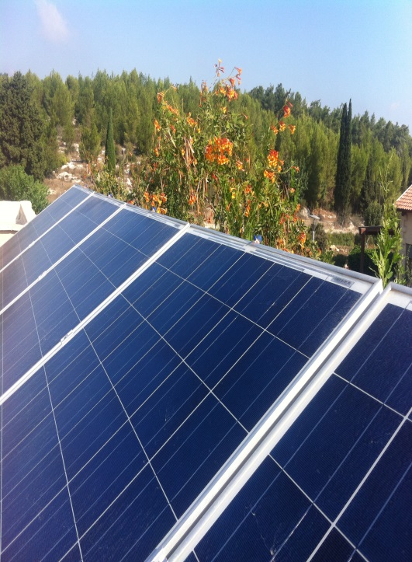



PV Cooler

Gadi Zadikoff

Founder

Kibutz Megido

Megido 19230

www.PVCooler.com

E:gadil@pvcooler.com

P: +972-54-6464036

F: +972-77-7870948